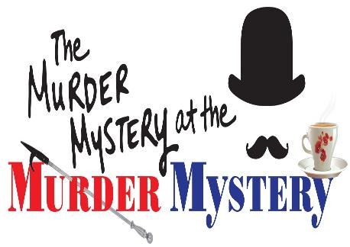

Cast List

Scarlet Mays/Ms. Polly ………………………..… Adeline M.
Holly Hanover/Mrs. Margaret Polk ……………….. Jenna E.
Sandy Smith/Gertrude Polk ……………………….… Cora R.
Misty Gere/ The Maid ……………………..………… Nykia B.
Richard Green/Mr. Frederick Polk ……………….. Gabriel L.
Tom Baines/Mr. Humphrey Black ………………….… Paul L.
Gary Ferguson/Inspectors Bradshaw & Fuller ……. Dean C.
Eric Stone ……………………………………………. Jonah T.
Brett Donahue …………………………………………. Levi S.
Susan Wells ………………………………………….. Sadie G.
Inspector Wright …………………………………... Arianna H.

Thank you all for your hard work so far. This is going to be a great show and a great group of students to work. Remember to bring your scripts to every rehearsal, pencil and water(not a metal one preferred so it doesn’t make a loud noise when knocked over), also you may bring a snack to munch on if you want.(just no nuts please, just in case anyone is allergic). Now, we all have our parts, keep working hard and making us proud.

Lots of Love, Your Fabulous Production Team!

